### 

**Special Agromet Advisories for CORONA virus (COVID-19) transmission in Bangladesh**

**Agromet Advisories**

Farmers and all other farm managements are advised to follow the guidelines of Government of Bangladesh to avoid infection and social transmission of CORONA virus (COVID-19). Precautions and safety measures should be taken up to prevent the Carona virus spread. Simple measures include social distancing, maintaining personal hygiene by washing hands with soap, wearing of face mask, drink hot water, stay at home and cleaning of implements and machinery. Farmers should not work in a group; consult with a doctor in case of any symptom. Please stay at home does not visit the field until it is very necessary.

**Salient Weather Conditions & Forecast**

As per the weather forecast of Bangladesh Meteorological Department (BMD) during next 24 hours’ weather may remain dry over the country. Light to moderate fog may occur at places over the river basins of the country during late night to morning. Night and day temperature may rise slightly over the country. Mild cold wave is sweeping over the regions of Srimangal, Panchagarh & Kurigram and it may abate. As per the outlook issued by BMD for next 72 hours is likely night temperature may rise further. During last four days, no rainfall occurred over the district and as per the quantitative medium range weather forecast; no rainfall is likely during next five days.  Detail Agromet advisory are given below:

**Boro paddy**

**Seedbed**

* In the early stages of the disease, 2 ml of Azoxystrobin or Pyraclostrobin should be mixed in one liter of water and sprayed in the afternoon in the seedbed to control seedling burns.
* If the seedbed becomes yellow, apply urea at the rate of 283 gm urea per decimal. If the seedlings are not green even after application of urea, gypsum fertilizer should be applied at the rate of 400 gm per decimal of land.
* Use light traps to protect the seedbed from the attack of brown plan hoppers. Catch the insects with the hand net and kill them. If the attack is high apply 125 ml imidacloprid per hectare.
* In case of thrips infestation, apply nitrogen fertilizer on the affected land. In case of high infestation apply 1.12 liters of malathion or 1.6 kg carbaryl or 1.12 kg isoprocarb / MIPC per hectare

**Wheat**

* Provide first irrigation during three leaves of seedlings (17-21 days after sowing), second irrigation during heading (50-55 days after sowing) and third irrigation during grain formation (75-80 days after sowing).
* Due to the rain, during heading of wheat are wet for 12-24 hours and the temperature is 16 degrees Celsius or more than that can lead to blast infection. Once during heading out as a preventive measure to control the disease, it is necessary to spray Nativo 75 WG or Navita 75 WG at the rate of 6 gm in 10 liters of water once and after 12-15 days.

**Maize**

* Provide first irrigation within 15-20 days of sowing, second irrigation within 30-35 days, third irrigation within 60-70 days and fourth irrigation within 65-69 days.
* Care should be taken to ensure that no water accumulates in the soil during flowering and grain formation of maize.

**Potato**

* Provide irrigation as required.
* Insect attack can occur in potato cut warm. When you see an infected cut potato plant, turn the soil around it, find the worms, collect them and kill them. Insect infestation can be reduced by applying Sex Pheromone Trap + Furadan 5g (Carbofuran) 20 kg / ha during land preparation and before final irrigation.
* Late blight is more likely to occur in the current weather. In this condition, to prevent the disease, the approved fungicide of Mancozeb group should be sprayed at the rate of 2 gm per liter of water after 7 days and the plant should be well soaked. In case of disease, irrigation should be stopped in the affected land till the disease is controlled. As soon as the disease occurs in one's own field or in the surrounding field, the plant should be well watered by spraying the approved fungicide.

**Mustard**

* Aphid can attack the mustard plant during flowering and fruiting. Only 50 gms of neem seeds should be broken, soaked in 1 liter of water for 12 hours, mixed with 2-3 gms of powdered soap and sprayed twice every 7 days. In case of severe infestation, Malathion 57 EC should be mixed in 2 ml per liter of water and sprayed twice in 10 days interval after 3 pm.
* In cold and humid weather, mustard stem rot can be attacked. As soon as the disease appears, apply Rovral 2.0 g / liter in water 3 times (growth stage, flower and grain formation stage).
* Provide irrigation as required.

**Vegetables**

* Apply light irrigation.
* In case of infestation of eggplant tip and fruit borer insects, cut and destroy the affected tip along with the insects. Insect reproduction is likely to be greatly reduced by using pheromone traps. Use spray of approval dose of insecticides, if necessary or recommended local organic insecticides may be used.
* In case of infestation of fruit borers in bean, control the insects by using IPM method
* In case of fly infestation in pumpkin vegetables, use pheromone and poison traps together. Pesticides of alpha ciphermethrin group can be used.
* In case of powdery mildew in pumpkin vegetables, apply hexaconazole or mencozeb.
* In case of Aphid attack in vegetables, use the approved dose of Malathion group pesticide.
* In case of mite infestation in chilli, 1 kg half-broken neem seeds in 20 liters of water for 24 hours and spray the water (after chopping) on ​​the underside of the leaves. If the infestation is severe, spray the spider mite 57 EC at the rate of 2.0 ml per liter of water or Vertimek 1.8 EC at the rate of 12 ml per 10 liters of water.

**Horticultural crops**

* Farmers are advised to go for inter cultural operations in mango orchard.
* In case of symptoms of Sigatoka disease on banana leaves, 0.5 ml of Score or 2 g of ***Noin or Bavistin*** or ***0.1 ml of Econazole / Folico*** should be mixed in every liter of water and sprayed 2-3 times at intervals of 15-20 days.
* In case of banana beetle infestation, apply ***Isoprocarb / MIPC*** group pesticides.
* In order to control coconut mite, miticide should be applied to the affected trees by cutting and burning the young coconut. In addition, miticide should be applied on the leaves of young trees in the vicinity.
* If millibugs attack guava, apply approved pesticides. This insect can also be controlled by spraying powdered soap at the rate of 05 g per liter of water.
* Take necessary action in case of infestation of fruit flies in guava.
* Apply light irrigation as required.

**Livestock**

* Livestock should be given urea processed straw as well as granular food especially oil cake and pulses husk.
* Vaccine the cattle to prevent disease.
* Keep the cattle house dry and clean.
* Black cloth or sacks can be used arround the house and hay on the floor at night to prevent cold.

**Poultry**

* Vaccine the chickens regularly to prevent disease.
* Keep the cattle house dry and clean. Keep the fence tight to prevent cold winds
* Black polythene or sacks can be used around the chicken’s house to protect the cold and rice husk on the floor to resist the cold.

**Fishery**

* If there are leaves fall trees on the banks of the pond, clean the leaves regularly.
* If the pH in the pond water is between 6-8, apply 1 kg of dolochun and 1 kg of salt per decimal every 15 to 20 days or every one month at the beginning of winter. If the pH is low, the amount of lime should be increased.
* When the water level in the pond decreases in winter, supply water as required; keep the concentration of fish normal or low.
* If the pond water is contaminated, change the water

**Realized Weather at different locations in the country**

**Rainfall for last 24 hours (till 10 AM on 10 February 2021) and maximum temperature on 09 February and minimum temperature on 10 February 2021 is given below:**

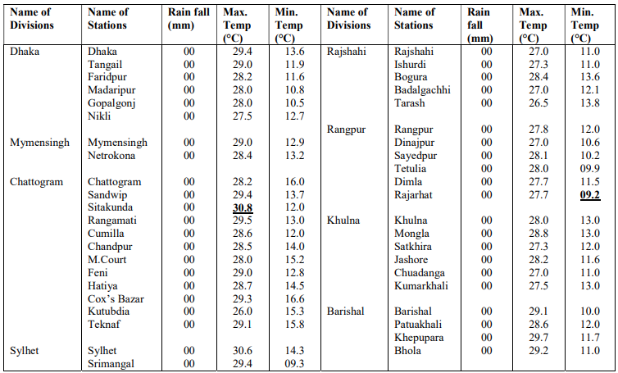

**Highlights:**

* Country average bright sunshine hour was 7.33 hours per day during last week.
* Country average free water loss during the previous week was 2.54 mm per day.

**Weather Forecast Valid for 24 Hours commencing 06 PM Today:**

**Forecast**: Weather may remain dry over the country. Light to moderate fog may occur at places over the river basins of the country during late night to morning.

**Temperature:** Night and day temperature may rise slightly over the country.

**Mild Cold wave**: Mild cold wave is sweeping over the regions of Srimangal, Panchagarh & Kurigram and it may abate.

**Spatial Distribution of weather parameters for the Week ending 09 February 2021**

|  |  |
| --- | --- |
|  |  |
|  |  |
|  |  |
|  |  |
|  |  |
|  |  |

**Weather Forecast and Advisory for the Period of 8.02.2021 to 14.02.2021**

Bright sunshine hour is likely to be from 6.50 to 7.50 hours per day during this week. Average free water loss is likely to be from 2.50 to 3.50 mm per day during this week.

* Weather may remain dry over the country during the 1st half and light (04-10 mm/d) rain/ drizzle may occur at one or two places over the country during the 2nd half of this period.
* Light fog may occur over the northern part and river basin area from mid night till morning during this period.
* Day and night temperature may unchange during the 1st half and slight rise in 2nd half over the country during this period.

**District Wise Quantitative Weather Forecast for next Five days from 10 Feb.-14 February 2021**

|  |  |
| --- | --- |
|  |  |
|  |  |
|  |  |
|  |  |

**Different Satellite Products over Bangladesh**

|  |  |
| --- | --- |
| NOAA/VIIRS BLENDED NDVI composite for the week. No. 04 (22 January-28 January) over Agricultural regions of Bangladesh | NOAA/ AVHRR BLENDED VCI composite for the week No. No. 04 (22 January-28 January) over Agricultural regions of Bangladesh |
| NOAA/ AVHRR BLENDED TCI composite for the week No. 04 (22 January-28 January over Agricultural regions of Bangladesh | NOAA/ AVHRR BLENDED VHI composite for the week No. 04 (22 January-28 January) over Agricultural regions of Bangladesh |