|  |  |  |
| --- | --- | --- |
| **Description: C:\Users\USER\Desktop\Govt. Logo.gif** | | |
|  | **Description: logo_DAE**  **কৃষি আবহাওয়া তথ্য পদ্ধতি উন্নতকরণ প্রকল্প**  **কম্পোনেন্ট সি-বিডব্লিউসিএসআরপি**  **কৃষি সম্প্রসারণ অধিদপ্তর** |  |

**Special Agromet Advisories Bulletins**

**for the following districts during 19-21 March 2020**

**Bagerhat, Bandarban, Barguna, Barishal, Bhola, Bogura, Brahmanbaria, Chandpur, Chattogram, Chuadanga, Cumilla, Dhaka, Dinajpur, Faridpur, Feni, Gaibandha, Gazipur, Gopalganj, Jamalpur, Jashore, jhalokati, Jhenaidah, Khagrachari, Khulna, Kishoreganj, Kushtia, Lalmonirhat, Lakshmipur, Madaripur, Magura, Manikganj, Meherpur, Munshiganj, Mymensingh, Naogaon, Narail, Narayanganj, Narsingdi, Natore, Netrokona, Naokhali, Pabna, Patuakhali, Pirojpur, Rajbari, Rajshahi, Rangpur, Satkhira, Shariatpur, Sherpur, Sriajganj, Tangail,**

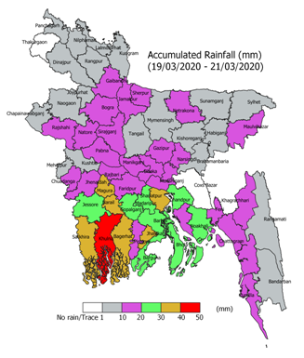

There is a chance of light to moderately heavy rainfall in large number of districts (52 ) in the country, as shown above, during 19-21 March 2020. This amount of rainfall may have impact on standing crops as well as cultivation of crops. In order to reduce the negative impact of this rainfall on the standing crops, following urgent agromet advisories are issued;

1. Avoid application of fertilizer, pesticides, irrigation on the standing crops.

2. Immediately harvest matured vegetables, lentil, onion & horticultural crops before 19th March 2020 and keep it safe and dry place, otherwise harvesting may be done after-21 March.

3. Special monitoring of blast disease is required as there is a chance of the disease due to likely rainfall along with clouding. If noticed, apply Nativo 75 WG 6 gm/decimal to control the disease

4. Clean the irrigation channel so that there should not be any standing water in the wheat, groundnut, maize, and lentil field as at the current stages of the crops are very sensitive to standing water.

6. Utilise this rainfall for maintaining of water level in boro paddy which are tillering to Hard Dough stages.

7. Provide mechanical support to the standing banana, sugarcane and other horticultural crops and also stacking of vegetables.

8. Due to the expected rainfall, there is every chance of optimum soil moisture congenial for sowing of jute crop. Advise to check the soil moisture and sow the seed.